**Samuel Vergara Martín**

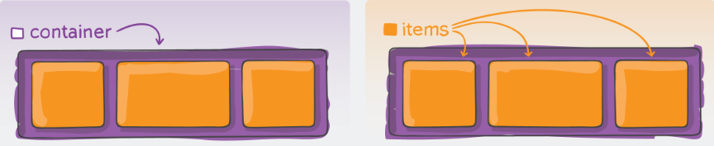

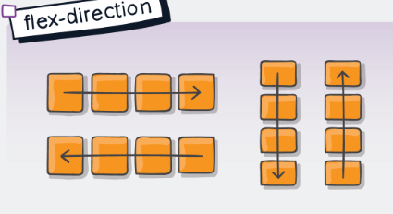

**flex-direction:** row | row-reverse | column | column-reverse

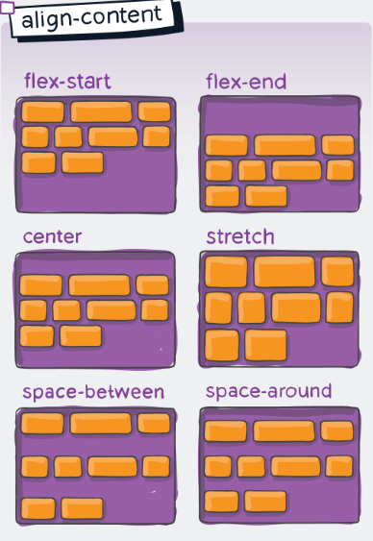

**align-content:** flex-start | flex-end | center | stretch | space-between | space-around

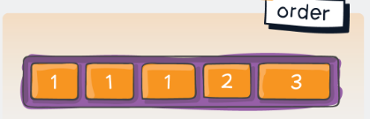

**order:** numero

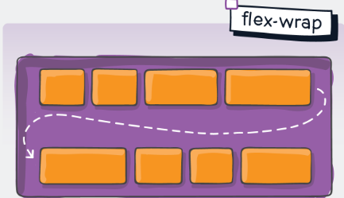

**flex-wrap:** 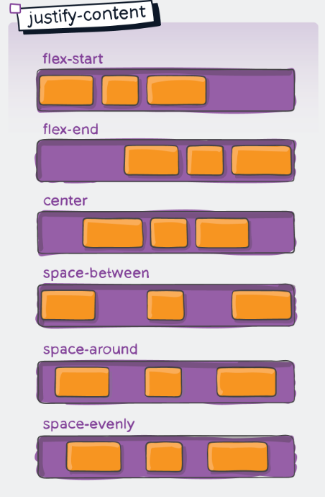nowrap | wrap | wrap-reverse

**justify-content:** flex-start | flex-end | center | space-between | space-around | space-evenly

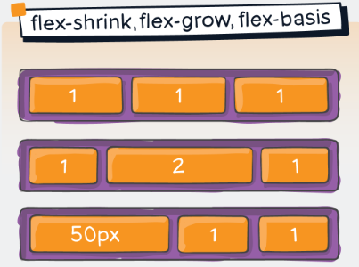

**flex-shrink:**

**flex-grow:**

**flex-basis:**

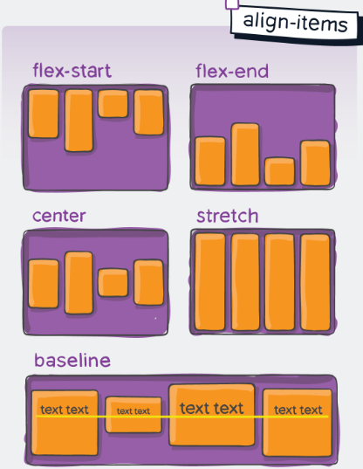

**align-items:** flex-start | flex-end | center | stretch | baseline

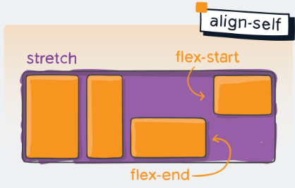

**align-self:** flex-start | flex-end | center | stretch | baseline

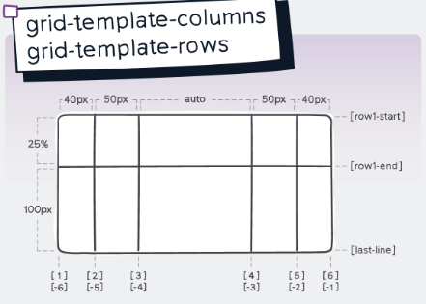**JORGE PEÑALVER QUIRÓS**

**grid-template-column:** valor | nombre

**grid-template-rows:** 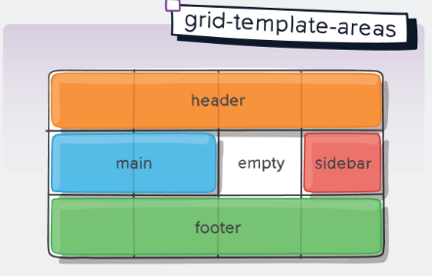valor | nombre

**grid-template-areas:** “nombre | . | none”

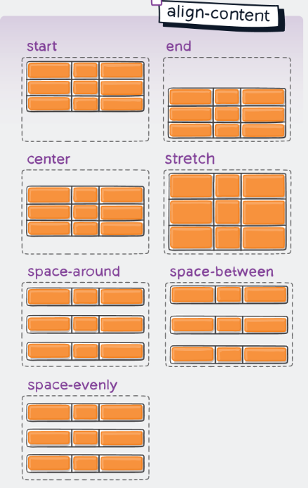

**align-content:** start | end | center | stretch | space-around | space-between | space-evenly

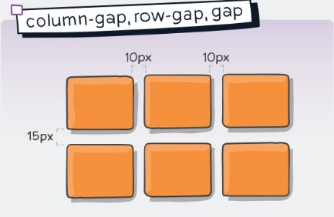

**column-gap:** valor

**row-gap:** valor

**gap:** row column

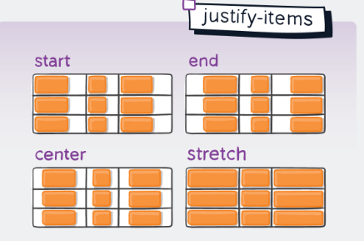

**justify-items:** start | end | center | stretch

**justify self:** start | end | center | stretch

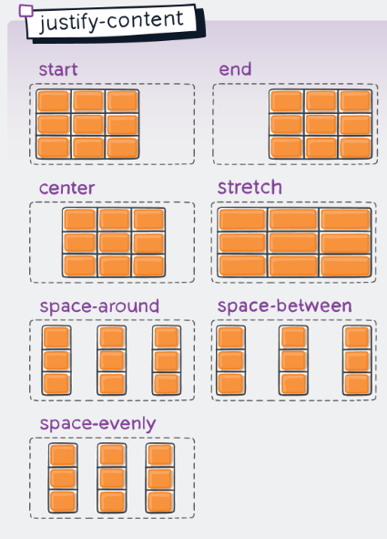

**justify-items:** start | end | center | stretch | space-around | space-between | space-evenly

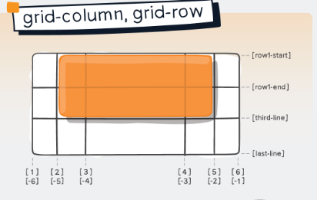

**grid-column:** start | end

**grid-row:** start | end

**grid-area:** row / column / row / column

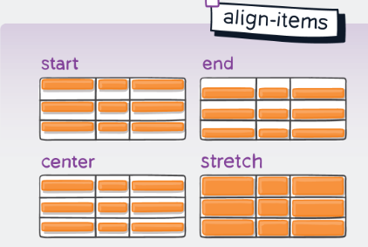

**align-items:** start | end | center | stretch

**align-self:** start | end | center | stretch